- Create sanity script. Create script file using vi test command
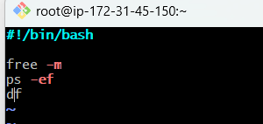
Save file using :wq! Command
Now give permission to test.bash file.
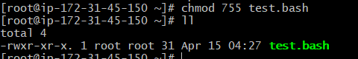
The file is executed
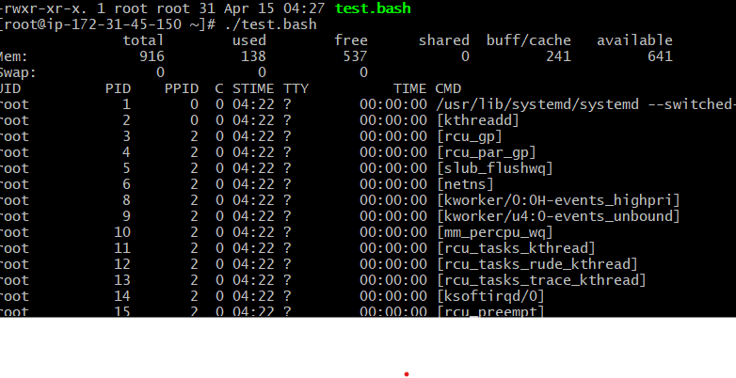
- How to check which shell is available or not using cat /etc/shells
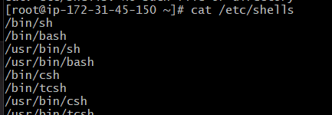
- How to switch shell. Using shell name
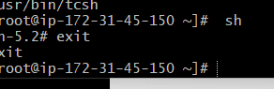
- Create file hello world.shell file in Hanif/script folder
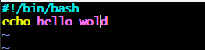
Change the permission of helloworld.file. using chmod 755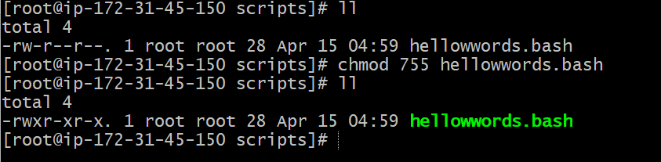
Run script using ./filename.bash
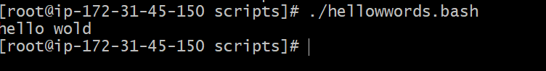
- There are tow way to execute path.
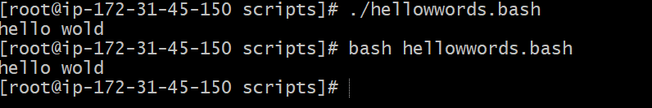
- Create abc.bash file
First use vi abc.bash command to create bash file
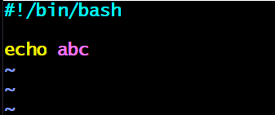
Assign permission to abc.bash file
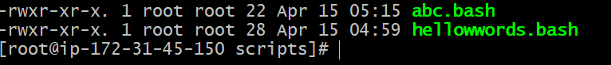
Out put is
- Write a script with script format.
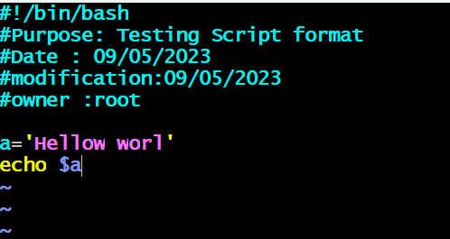
Run script
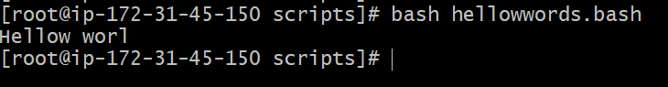
- Create script
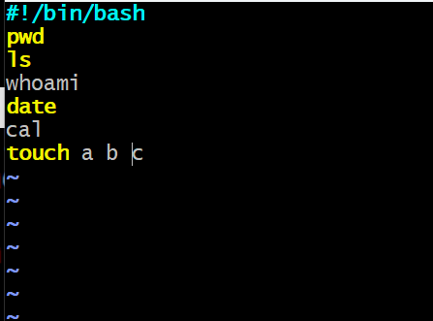
Out put is below screen
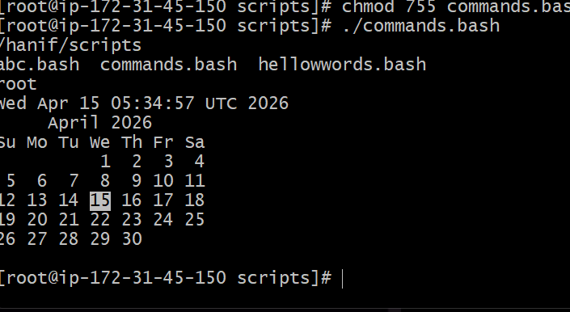
- Create admin.bash script
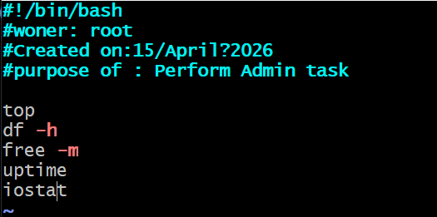
Run the script using ./ filename.bash
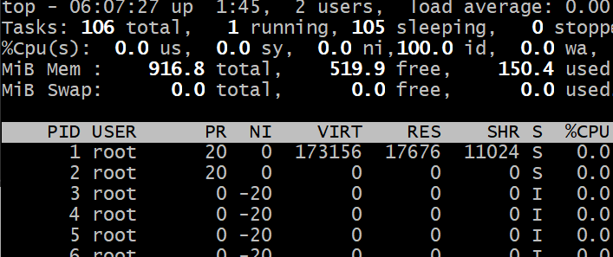
In output I see only top command result other command is not executed because top command hold the session so I need to change in script
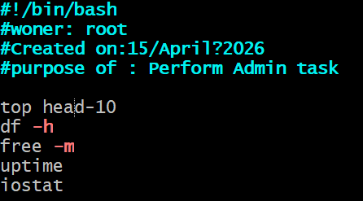
Now we run script with complete result.
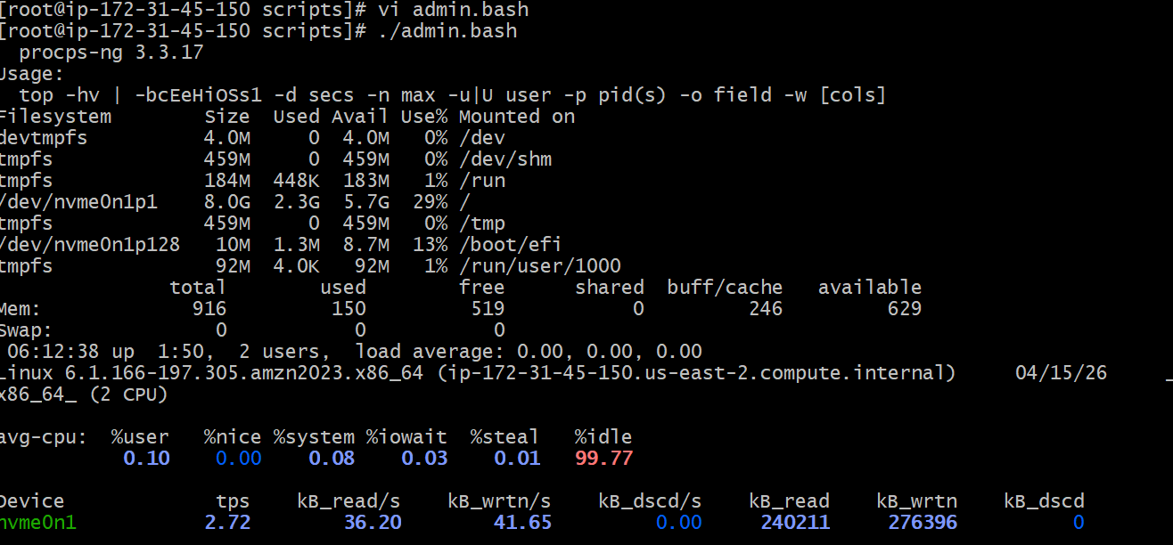
- Create script with variable
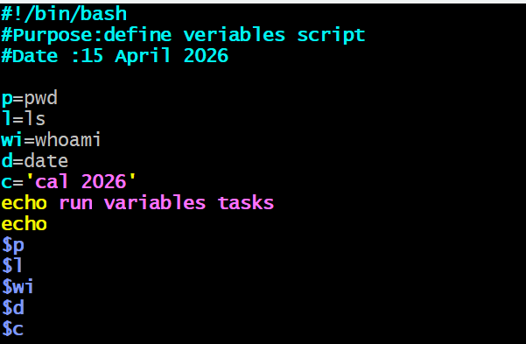
Result
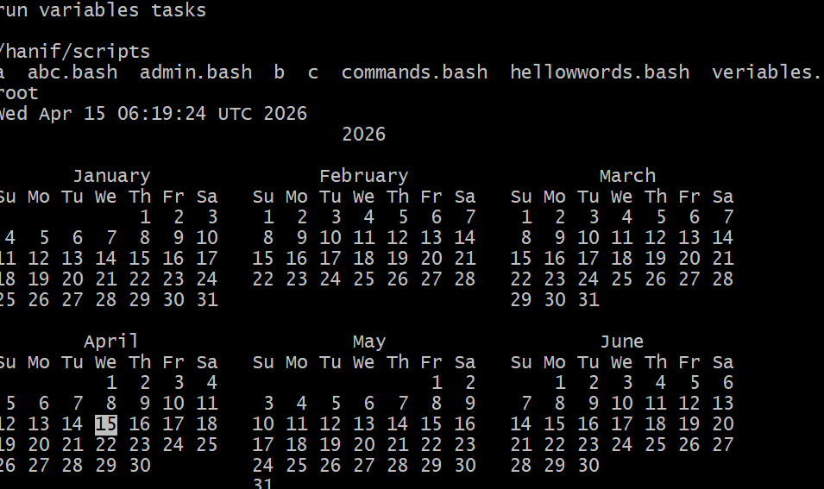
- Create script to take input from user and display
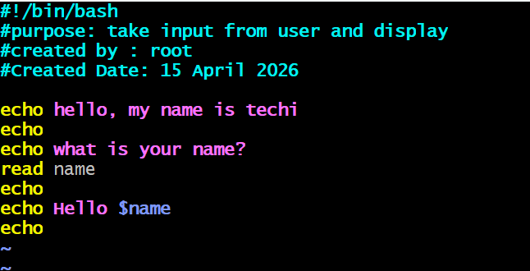
Result
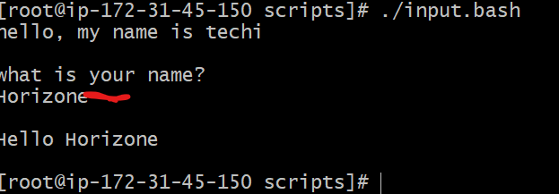
- Write a script to display host name
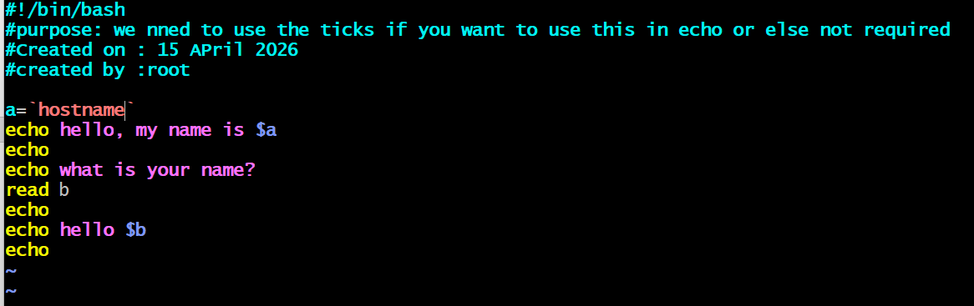
Out put is
